
SPECIALIST MATHS
TRIAL EXAMINATION 2
SOLUTIONS
2012

SECTION 1 – Multiple-choice answers

1. B 7. D 13. E 19. C
2. D 8. E 14. C 20. B
3. A 9. B 15. C 21. B
4. B 10. C 16. B 22. C
5. D 11. E 17. E
6. D 12. D 18. A

SECTION 1 - Multiple-choice solutions

Question 1

The equation of the ellipse is
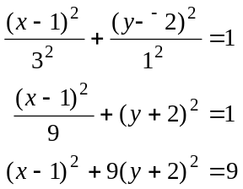
The answer is B.

Question 2

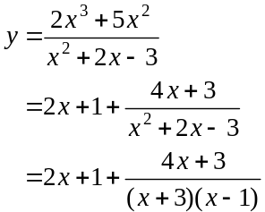
The graph has two vertical asymptotes; as well as an oblique asymptote with equation 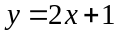.
In total there are 3 straight line asymptotes so .
The answer is D.

Question 3

The function 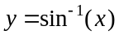 has a domain of .
So the function 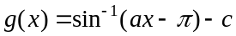 will have a domain given by
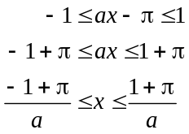
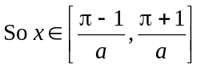
The answer is A.

Question 4

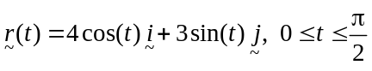
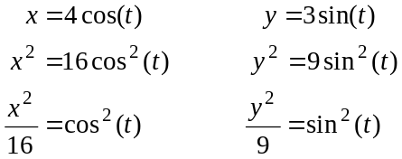
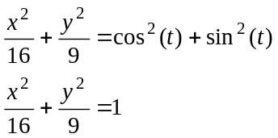

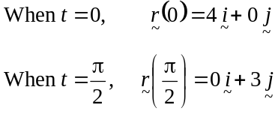
So the path is from 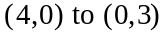 expressed
in Cartesian coordinates.
So and 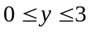.

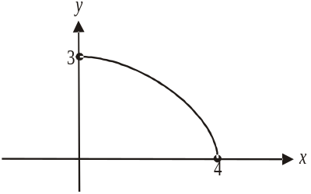

The answer is B.

Question 5

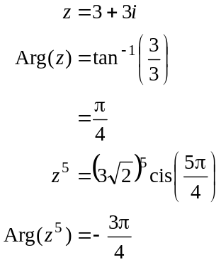
Note that 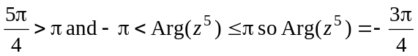.
The answer is D.

Question 6

Given that the polynomial has real coefficients we can use the conjugate root theorem which states that if a polynomial has real coefficients then the solutions to the polynomial equation must occur in conjugate pairs.
So if is a solution then must also be a solution.
If is a solution then must be also.
If is a solution then must be also.
If 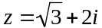 is a solution then 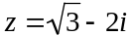 must be also.
So we have eight solutions plus the solution which does not have an imaginary part and therefore does not have a complex conjugate.
The minimum number of solutions is 9.
The answer is D.

Question 7
Method 1 – using CAS
Using CAS solve the equation 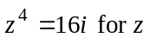 and express the solutions in polar form.
Those solutions are represented on the diagram by 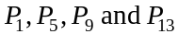.
The answer is D.
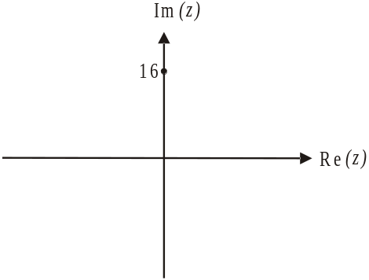
Method 2 – by hand
Let 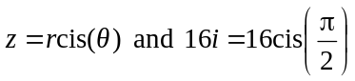
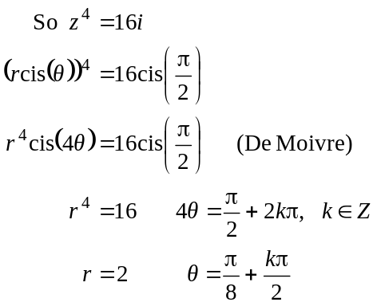
There are 4 solutions spaced evenly around a circle of radius 2.
If 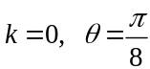, so the first point representing a solution is , the next is located at 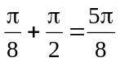 which is 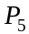, the next is at 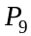 and the last is at 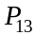.
The answer is D.

Question 8
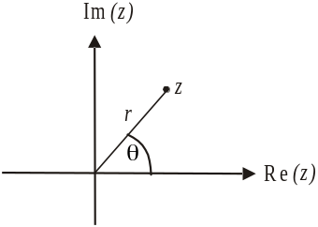
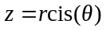

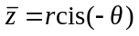
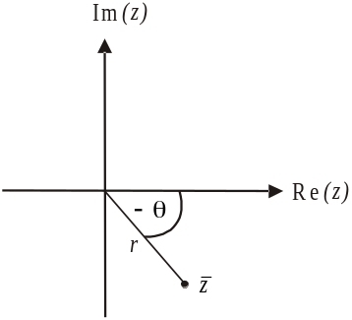

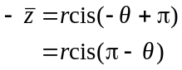
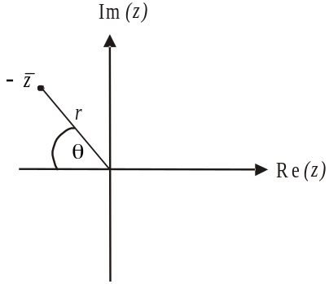

This is the equivalent of rotating anticlockwise about the origin by . Since multiplying a complex number by i rotates it anticlockwise about the origin by 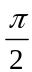, multiplying a complex number by 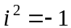 rotates it by then by again. So the modulus is r and the argument is 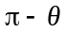.
The answer is E.

Question 9

Method 1 – sketch the graphs
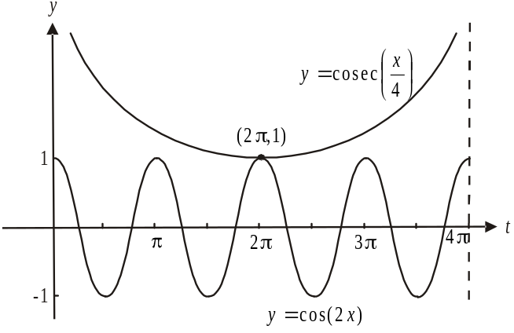

The graphs intersect once.
The answer is B.

Method 2
Solve 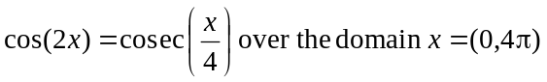
So there is one point of intersection.
The answer is B.

Question 10

Since the vectors 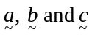 form a triangle with diameter along and all vertices of the triangle are in contact with the circle, then the angle between 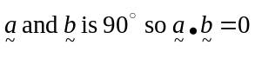.
Using Pythagoras Theorem, option B is correct.
Also, 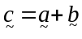 using vector addition and similarly, 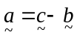 so option E can be written as
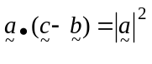
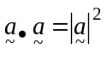
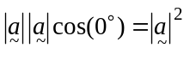
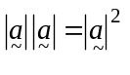
Option C is not true since the length of 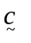 is less than the sum of the lengths of 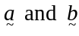
The answer is C.

Question 11

For option A, 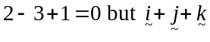 is not a unit vector.
For option B, 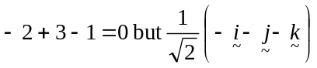 is not a unit vector.
For option C, .
For option D,
For option E, 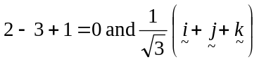 is a unit vector
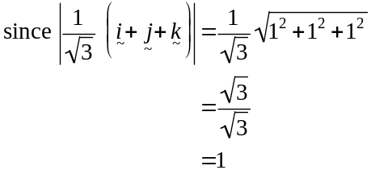
The answer is E.

Question 12

Using the scalar product,
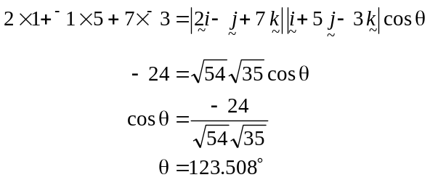
The closest answer is 123.5°.
The answer is D.

Question 13

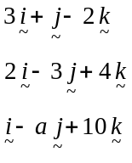
Now, 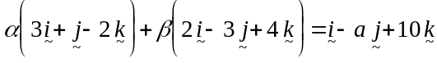
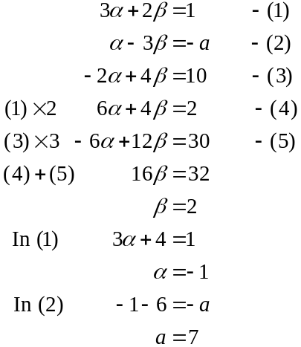
The answer is E.

Question 14
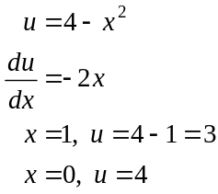
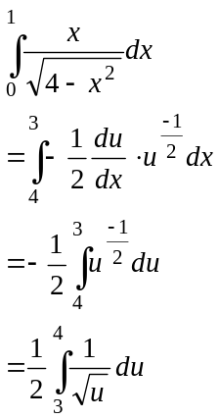
The answer is C.

Question 15

The gradient of a line joining point 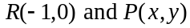 is equal to 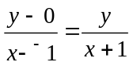.
This gradient is equal to 2 more than the gradient of the tangent to the curve at P which is 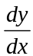.
So 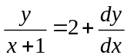 is the differential equation.

Rearranging,
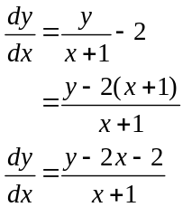
The answer is C.

Question 16

For 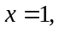 the gradients on the direction field are variable whereas for option A the gradient should equal zero. We can eliminate option A.
The direction field shown has a gradient of zero at 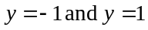. This eliminates options C and E which can never have a zero gradient.
For option D the gradient should be zero where 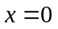 but looking at the direction field the gradients are variable where .
The answer is B.

Question 17

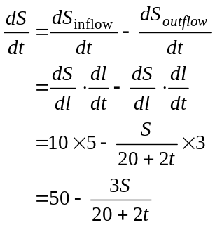
Note that the amount of sugar per litre in the syrup flowing out is given by 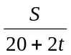where S is the amount of sugar in the vat at any time t and is the volume of the syrup in the vat at any time t.
The answer is E.

Question 18

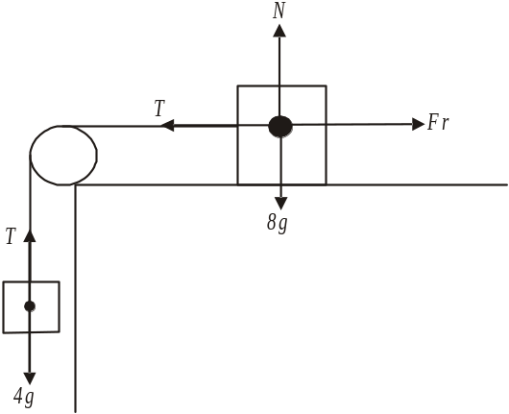

Around the 4kg mass

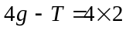
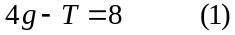

Around the 8kg mass
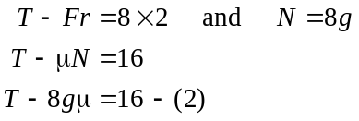

Adding (1) and (2) gives

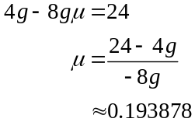
The closest answer is 0.19.
The answer is A.

Question 19
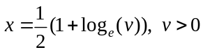
Method 1
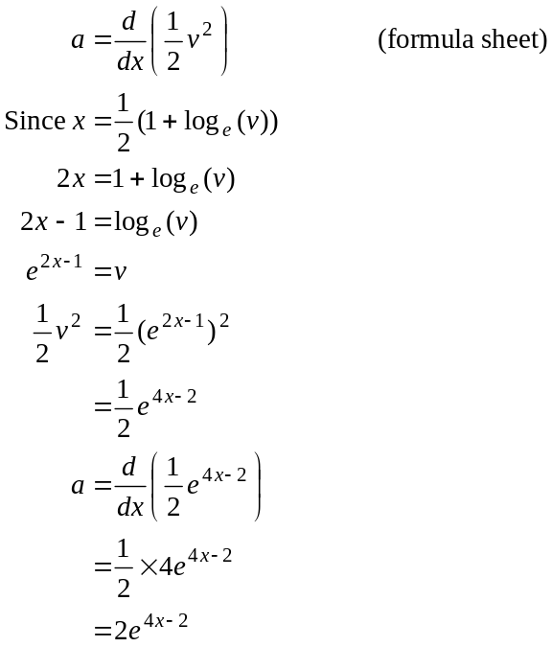
The answer is C.

Method 2
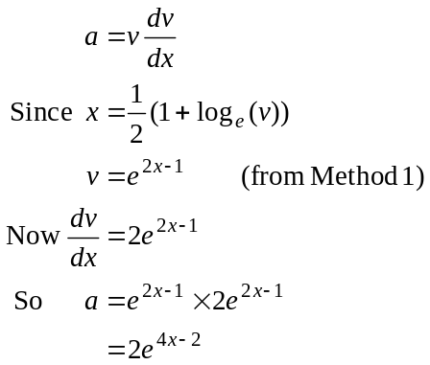
The answer is C.

Method 3
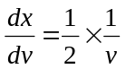
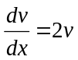
So 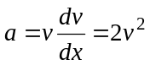
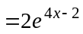
The answer is C.
Question 20

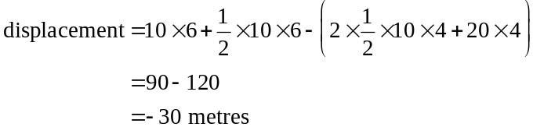
The answer is B.

Question 21

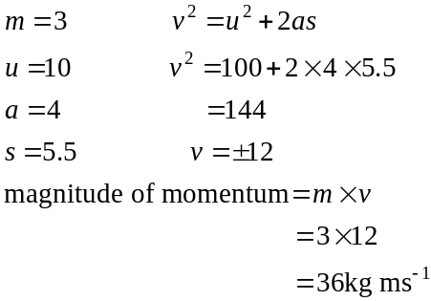
The answer is B.

Question 22

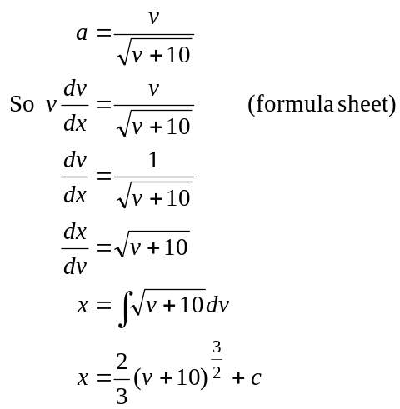
When 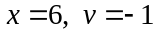
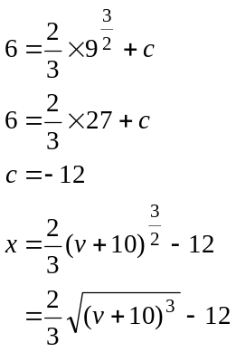
The answer is C.
SECTION 2

Question 1

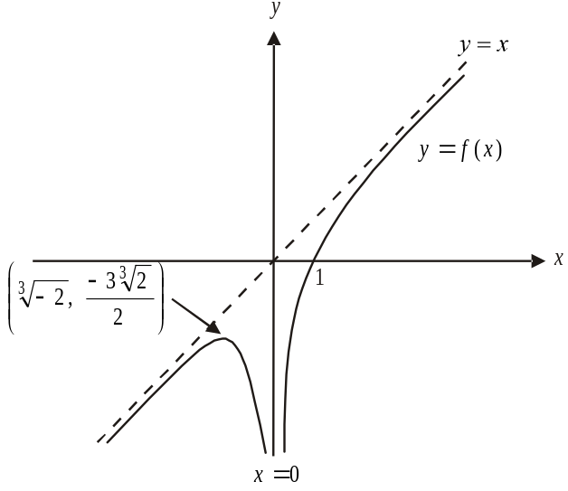

x-intercept occurs when 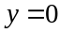
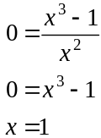
(1 mark) for correct x-intercept

Now 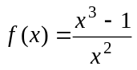
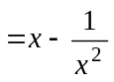

vertical asymptote occurs at
non-vertical asymptote occurs at
(1 mark) for correct asymptotes

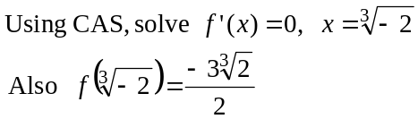
A stationary point occurs at 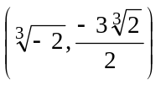
(1 mark) for correct stationary point
(1 mark) – correctly drawn graph
with correct asymptotic behaviour

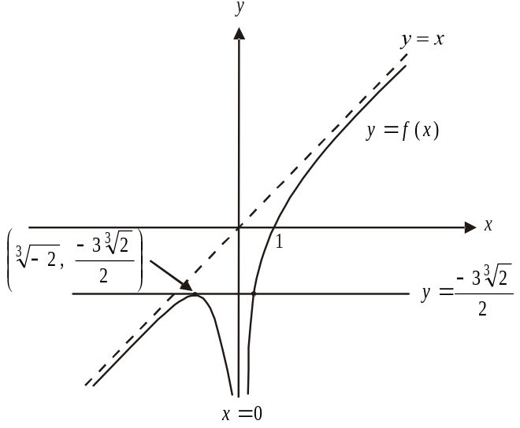

Using the graph from part a., we see that there are two
points of intersection between the graphs of 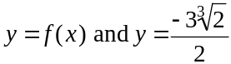.
So 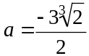
(1 mark)
For any other values of a there is one solution or 3 solutions.

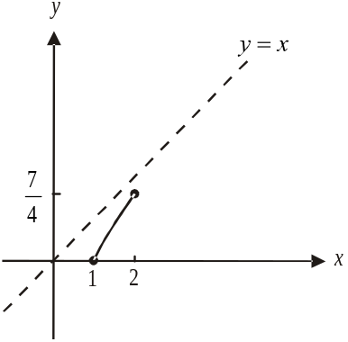
- i. When ,
we have 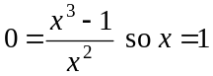.

When 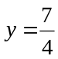,
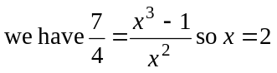.

The definite integral is therefore 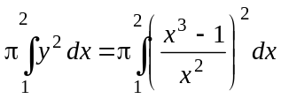.
(1 mark) – correct terminals
(1 mark) – correct integrand
- Using CAS, 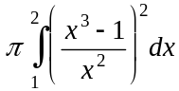
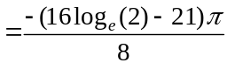 cubic units
(1 mark)

- 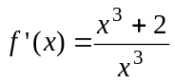 (1 mark)
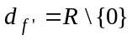 (1 mark)

e.
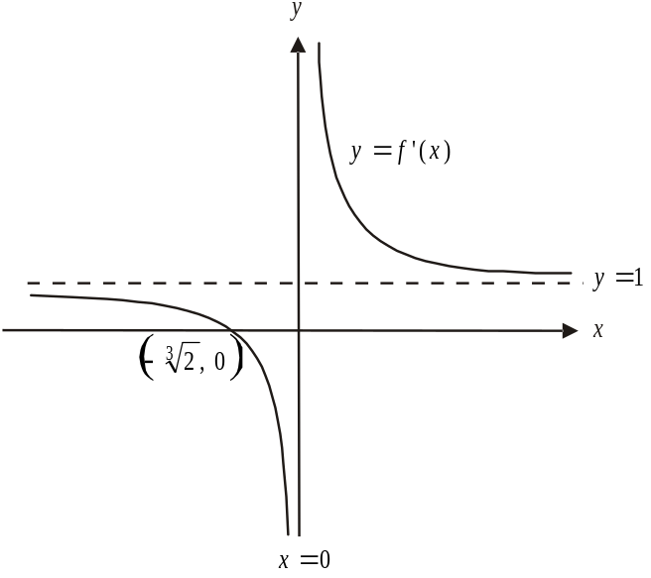

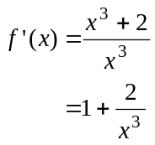
The graph of 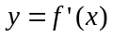 has a vertical asymptote with equation and a horizontal asymptote with equation 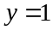.
It also has an x-intercept at 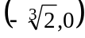.
(1 mark) – correct asymptotes
(1 mark) – correct shape including x-intercept

f. 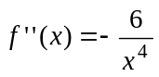
The graph of 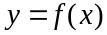 will have a point of inflection if 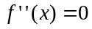 (and 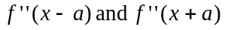 are opposite in signs where a is a constant)
Now 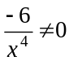 so there is no point of inflection.
(1 mark)
Total 13 marks

Question 2

- 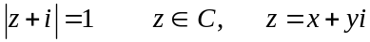
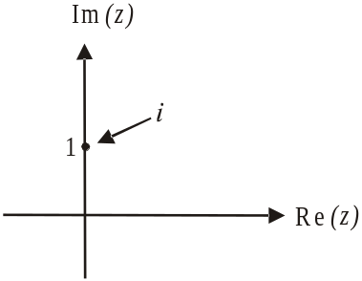

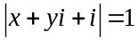
Substitute 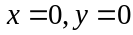 into this equation
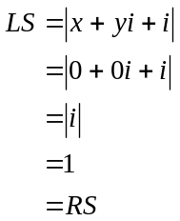
Have verified.
(1 mark)
(Note that the complex number i is shown on the Argand diagram.
The distance of this point to the origin i.e. is equal to one.)

- 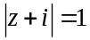
(1 mark)
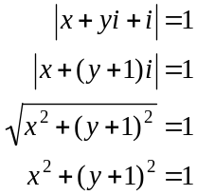
as required.
(1 mark)
- First, find the Cartesian equation of L.
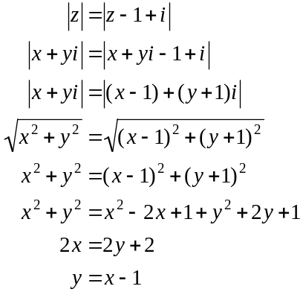
(1 mark)
Do a quick sketch.
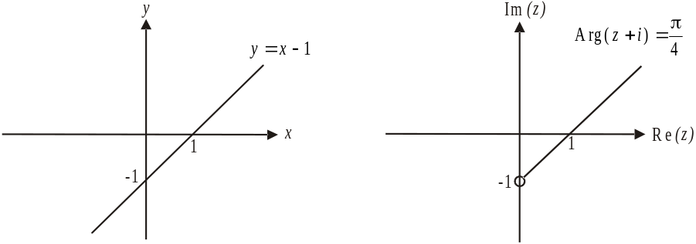

So 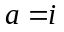.
(1 mark)
- i. From part b. we have 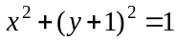 and from part c., we have 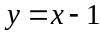.
Substitute the linear equation into the equation of the circle.
Solve using CAS or by hand.
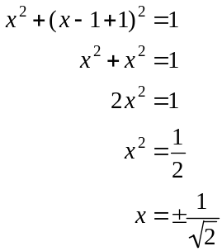
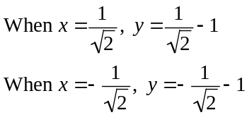
Points of intersection are 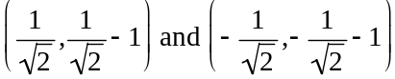

(1 mark) for obtaining the correct equation of intersection
(1 mark) for obtaining the correct points of intersection

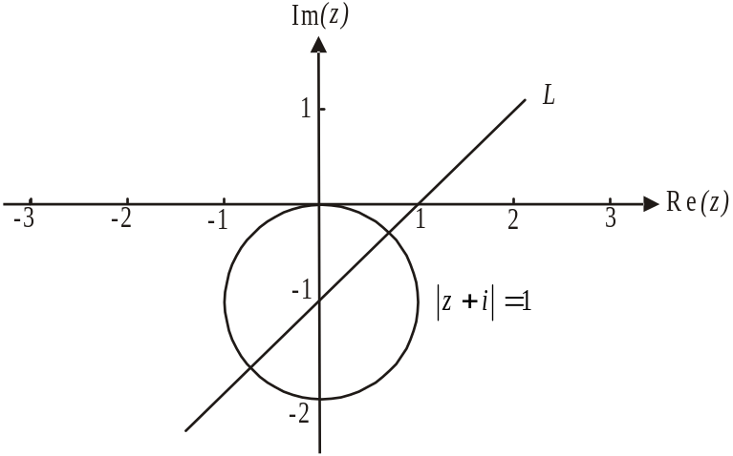

(1 mark) – graph of L
(1 mark) – graph of 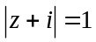

- i.
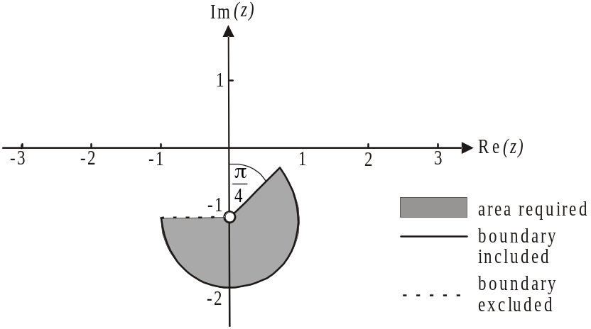

(1 mark) – shading within the circle
including the boundary
(1 mark) – for correct boundaries
ie. the point 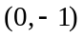 is not included,
the boundary between 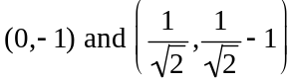 is included
and the boundary between and 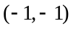 is not included

- 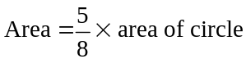
(1 mark)
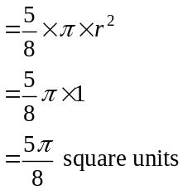
(1 mark)

Total 13 marks

Question 3
(1 mark)

- 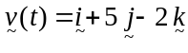
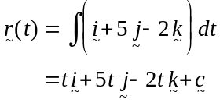
(1 mark)
At ,
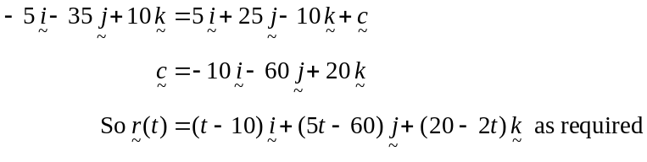
(1 mark)

- The plane lands when the vertical component equals zero.
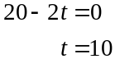
So it takes 10 seconds.
(1 mark)

- When the plane lands at 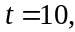 we have 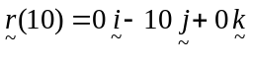
So the plane lands 10m from the operator.
(1 mark)

- Method 1

Now, 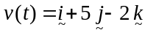 so the plane is travelling at constant speed given by
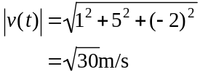
(1 mark)
It travels at this speed for 10 seconds. So it travels 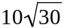 metres.
(1 mark)
Method 2
(1 mark)
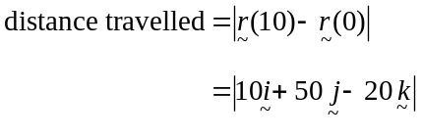
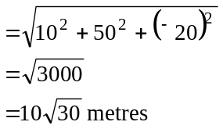
(1 mark)
- The position vector of the picnic bench is 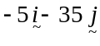. The position vector of the landed plane is 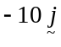 (from part c.). (1mark)
Method 1
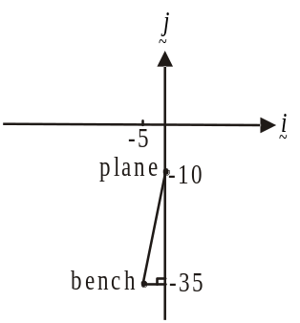
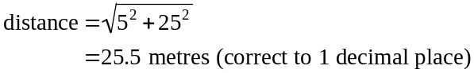

(1 mark)
Method 2
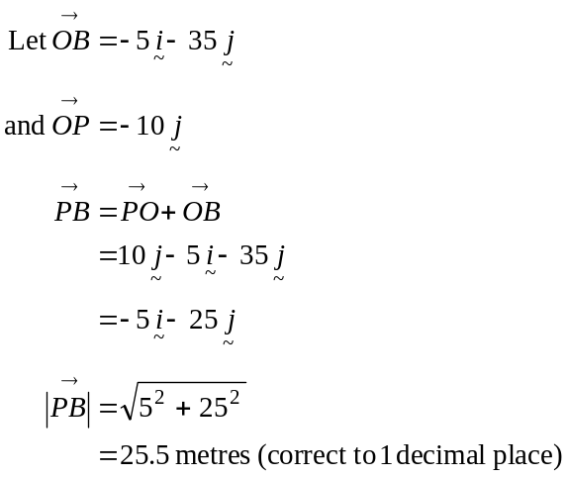
(1 mark)

- Since the direction of the plane is given
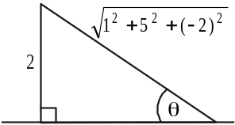
by the velocity vector, we want to find the angle
that the velocity vector makes with the horizontal ground.
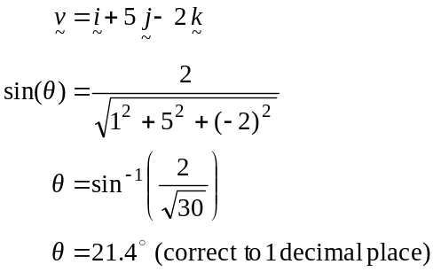
(1mark) - use of velocity vector
(1 mark) – correct answer

Total 10 marks

Question 4
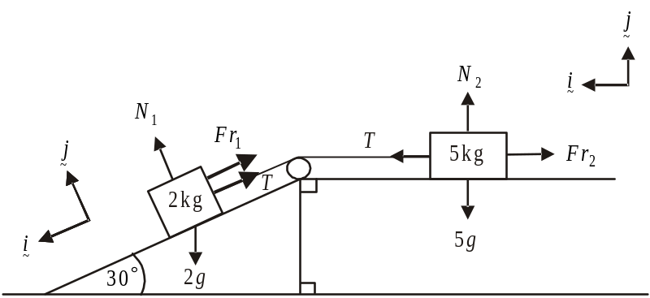

- Since the acceleration of the 2 kg mass is down the plane, the friction force acts up the plane.
Around the 2 kg mass:
(1 mark)
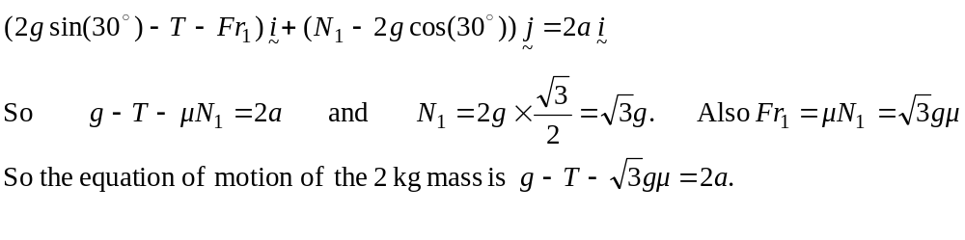 (1 mark)

- Since the acceleration of the 2kg is down the plane, the acceleration of the 5kg mass is towards the left along the plane so the friction forces act towards the right.
Around the 5kg mass:
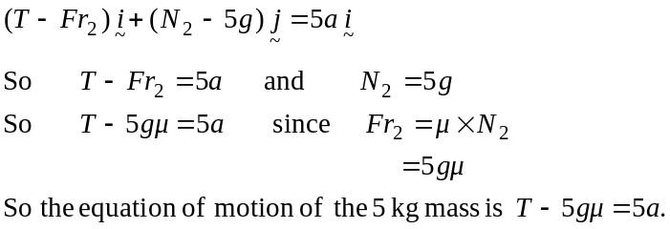
(1 mark)

- 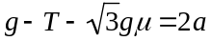 from part a.i.
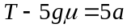 from part a.ii.
Adding respective sides, we obtain,
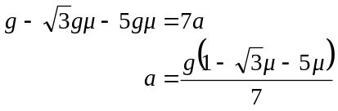
(1 mark)

- When the system is in equilibrium, .
From b., 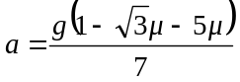
Solve 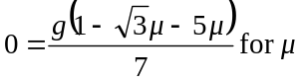 by CAS or by hand.
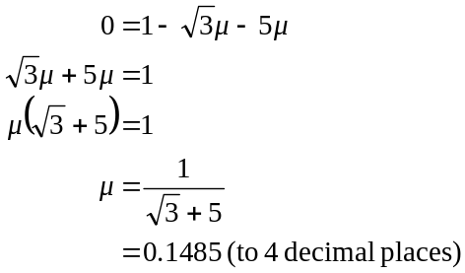
(1 mark)
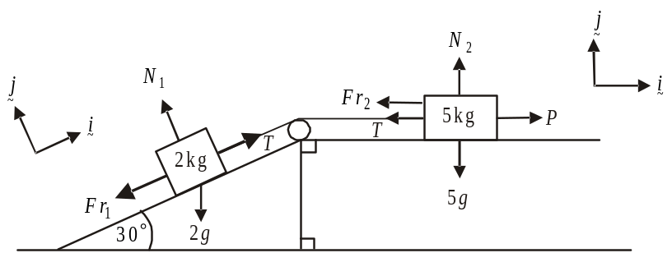

Since the pulling force causes acceleration of 2m/s² to the 2 kg mass up the slope, the friction force acts down the slope. Similarly the pulling force causes acceleration of 2m/s² to the right of the 5 kg mass so the friction force will act to the left.

Around the 2 kg mass.
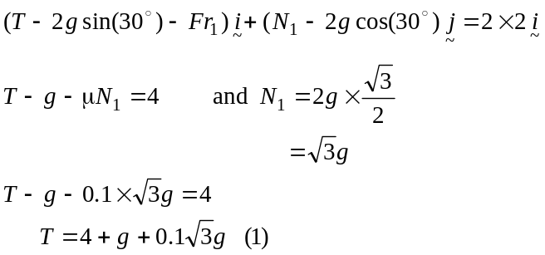
(1 mark)
Around the 5kg mass
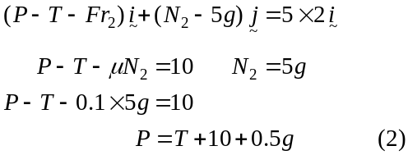
(1 mark)
Combining (1) and (2)
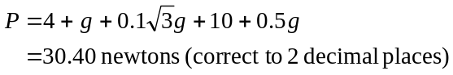

(1 mark

- If the pulling force P is sufficiently small, the system will be at the point of sliding down the slope (for the 2 kg mass) and to the left (for the 5 kg mass).
At this point 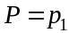.
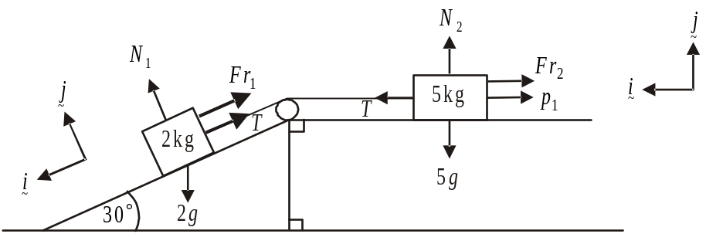

The friction forces will oppose this motion as shown. This is the same scenario for the 2 kg mass as part a. part i. except because the system is at the point of sliding down the plane but not actually sliding down the plane, 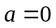. So using the equation of motion from part a., with , we have

Around the 2 kg mass
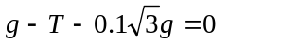(1)

Around the 5kg mass is different because an extra force 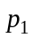 is now involved.

Around the 5kg mass.
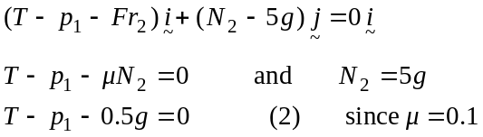
(1 mark) for equations (1) and (2)
Adding (1) and (2)
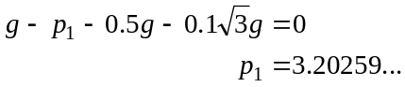
So 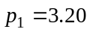 newtons (correct to 2 decimal places)
(1 mark)
If the pulling force P is sufficiently large, the system will be at the point of sliding up the slope (for the 2 kg mass) and to the right (for the 5 kg mass). At this point 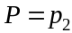.
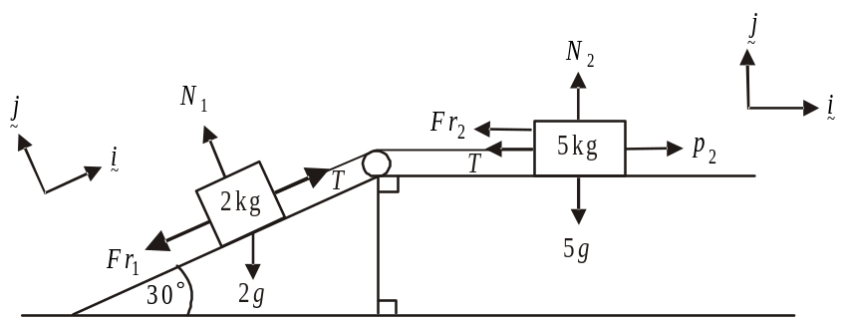

The friction forces will oppose this motion as shown.
Note that this is the same scenario as in part d except that in this case .

Around the 2kg mass:

Around the 5kg mass:

Adding (1) and (2)
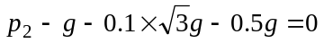
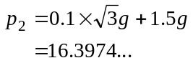
So 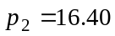 newtons (correct to 2 decimal places)
(1 mark)
Note that in part d. where P produced movement of the system up the slope and to the right , . We would have expected 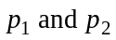 therefore to be less than this.
This is a way of checking that your answers for are feasible.
Total 11 marks

Question 5

- 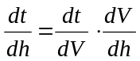 (chain rule) (1 mark)
Given 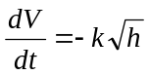
We have 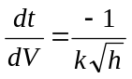
Now for a cone, 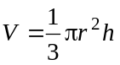 (formula sheet)
From the diagram, , since the semi-vertex angle of the cone is 45°.
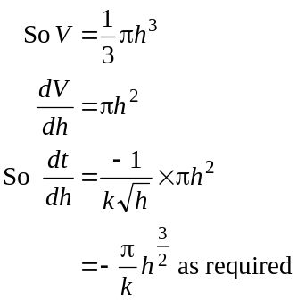
(1 mark)

- i. 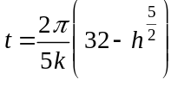
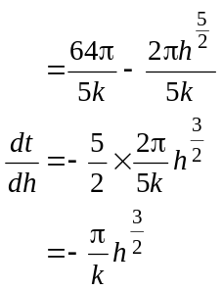
(1 mark)
So the solution satisfies the differential equation.

When 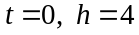 (initial condition)
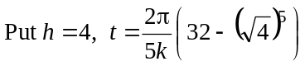
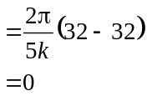
So the solution satisfies the initial condition.
(1 mark)
When 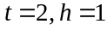
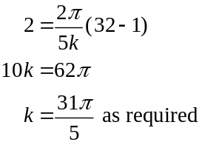
(1 mark)

- From part b., 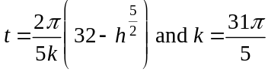
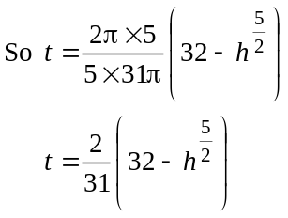
When the tank is empty,
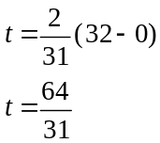
It takes 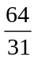 hours for the tank to empty.
(1 mark)

- i. 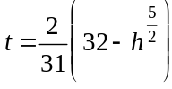
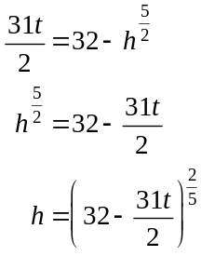
(1 mark)
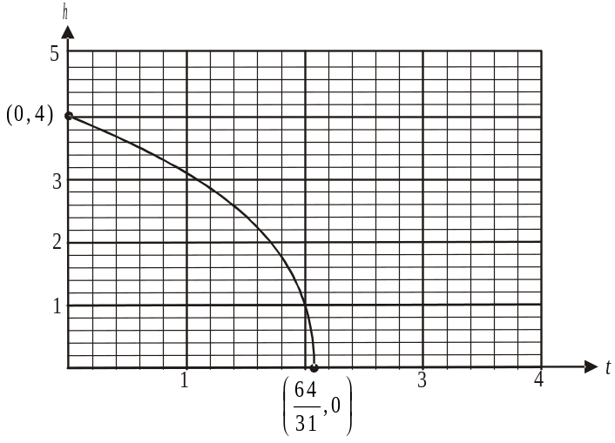

From part c., the right endpoint of the graph occurs at 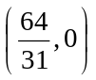.

(1 mark) - correct shape
(1 mark) - correct endpoints

- Method 1

We are given in the question that 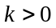.
We found in part b. that for the liquid currently in the tank, 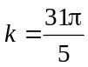.

Now since , the smaller the value of k the slower the tank will empty.
So if the tank were to contain a different liquid that caused the tank to empty more slowly, then 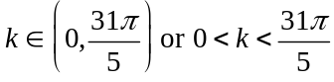.

(1 mark) – left endpoint
(1 mark) – right endpoint

Method 2
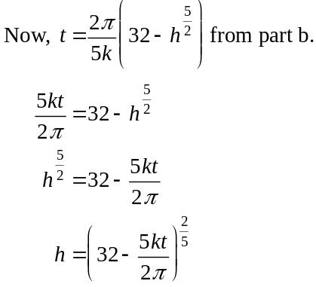
Using CAS sketch the graph of 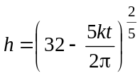 for different values of k.
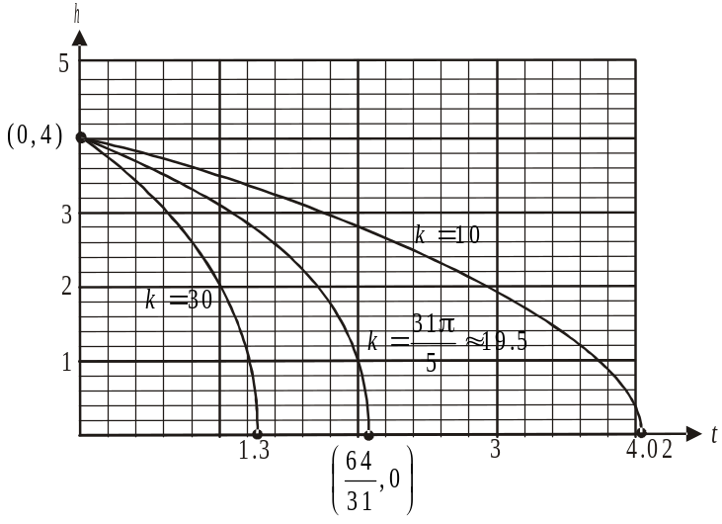

As k decreases the time it takes for the tank to empty increases (i.e. the t-intercept increases).
Since (given) the required values are .
(1 mark) – left endpoint
(1 mark) – right endpoint
Total 11 marks

